PXO: Poly-XTAL operations V10.00. Free MATLAB codebase to generate and analyse complex 2D poly-crystalline grain structures

**TEST CASES V1.0**

Sunil Anandatheertha1

1PhD student, Faculty of Engineering and Computing, Coventry University, Coventry CV1 5FB, UK

**Author contributions**

|  |  |
| --- | --- |
| Sunil Anandatheertha | Conceptualization, Software development and maintenance, documentation and manuscript preparation |

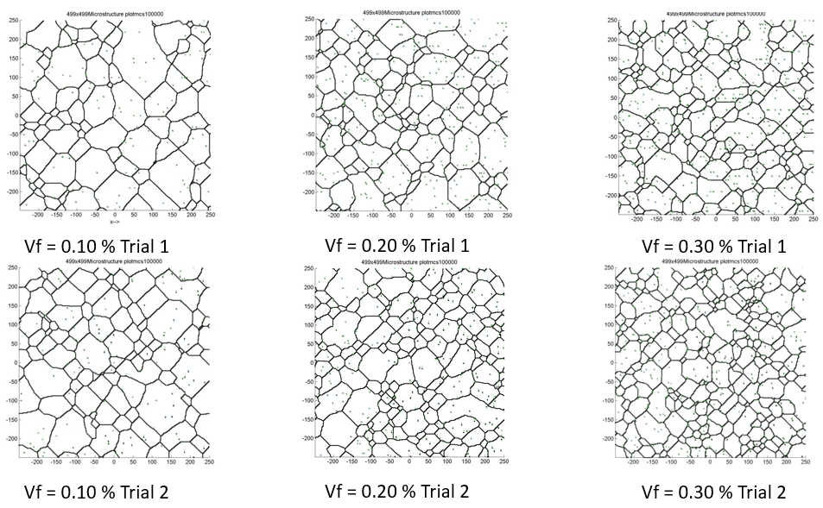

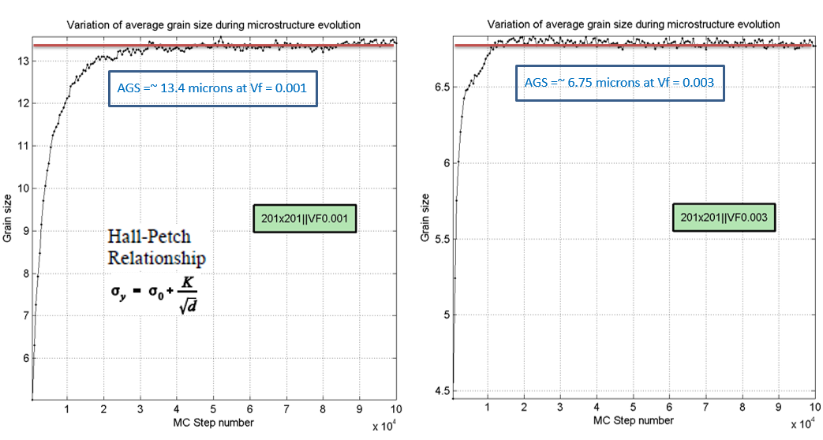

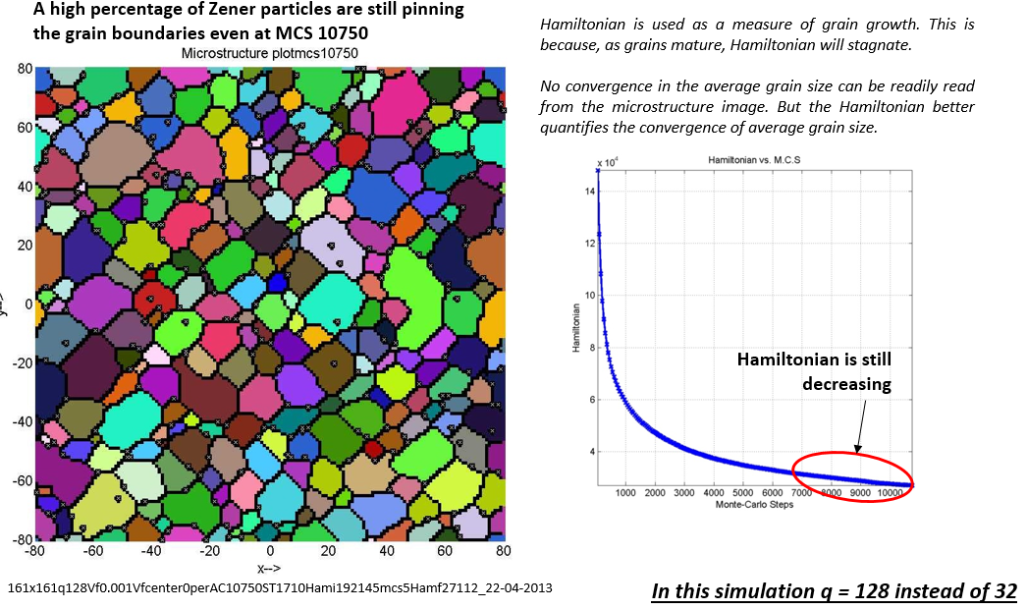

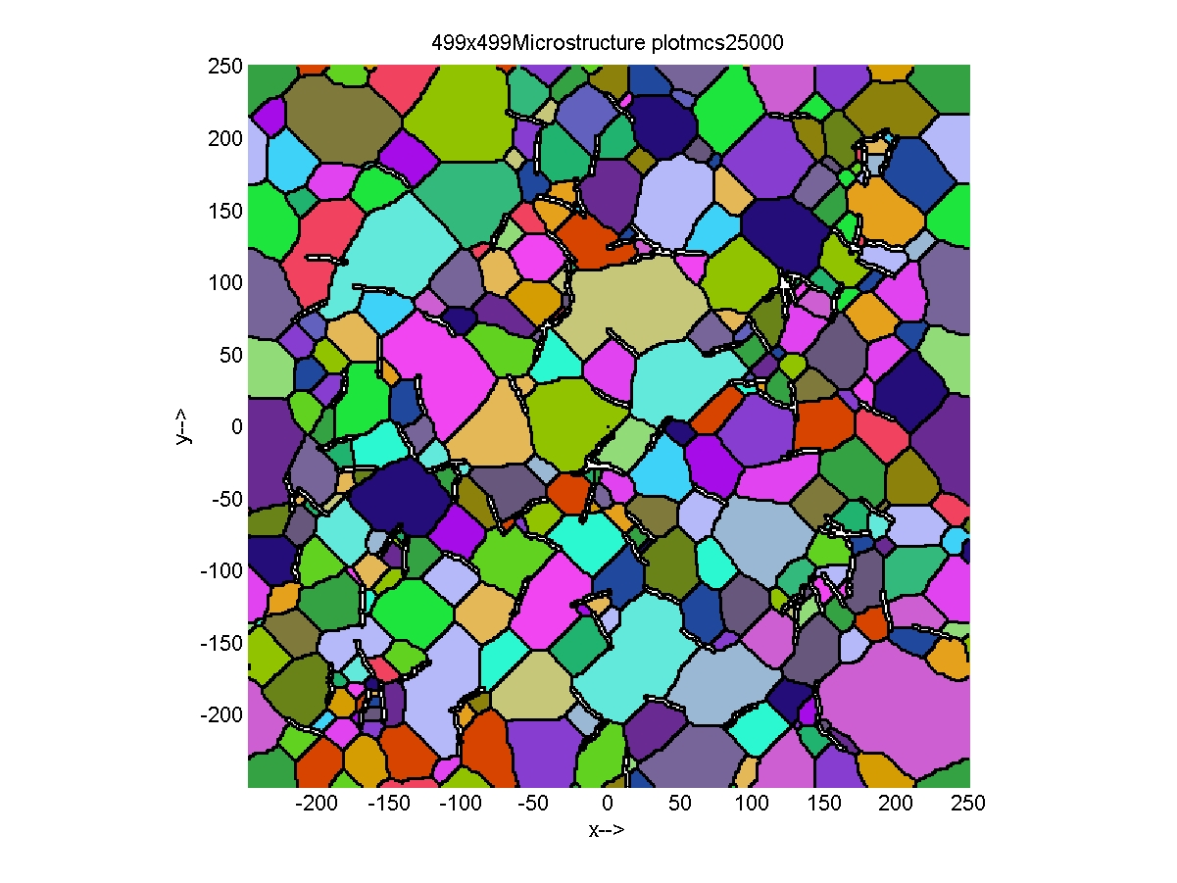

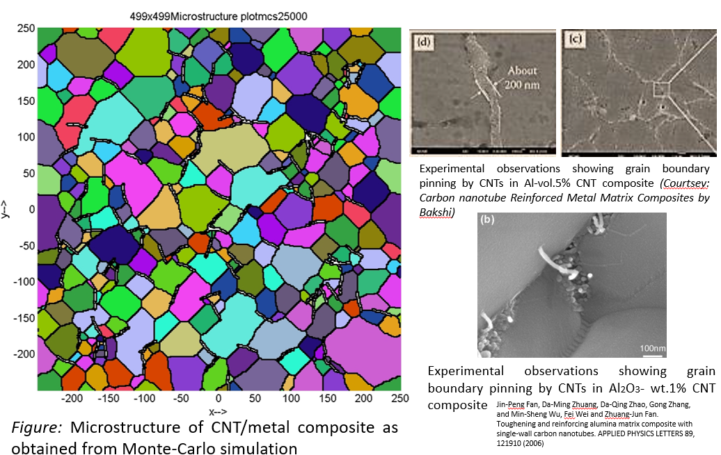

Experimental observations showing grain boundary pinning by CNTs in Al-vol.5% CNT composite *(Courtsey: Carbon nanotube Reinforced Metal Matrix Composites by Bakshi)*

*Experimental observations showing grain boundary pinning by CNTs in Al2O3- wt.1% CNT composite*

Jin-Peng Fan, Da-Ming Zhuang, Da-Qing Zhao, Gong Zhang, and Min-Sheng Wu, Fei Wei and Zhuang-Jun Fan. Toughening and reinforcing alumina matrix composite with single-wall carbon nanotubes. APPLIED PHYSICS LETTERS 89, 121910 (2006)

